**ChE 320 Spring 2017**

**Practice Exam 1 (100pts)**

**Instructions: Please read the questions carefully and plan accordingly before answering.**

Name:_____________________________________________ ________________________

Signature:___________________________________________________________________

Question 1. (20 pts)

A study was performed on wear of a bearing *y* and its relationship to *x1* = oil viscosity and *x2* = load. The following data were obtained.

|  |  |  |
| --- | --- | --- |
| ***y*** | ***x1*** | ***x2*** |
| 193 | 1.6 | 851 |
| 230 | 15.5 | 816 |
| 172 | 22.0 | 1058 |
| 91 | 43.0 | 1201 |
| 113 | 33.0 | 1357 |
| 125 | 40.0 | 1115 |

Create two scatter diagrams of the data. What do you anticipate will be the sign of each sample correlation coefficient?

Both sample correlations will be negative. (10 pts)

y versus x1: y versus x2:

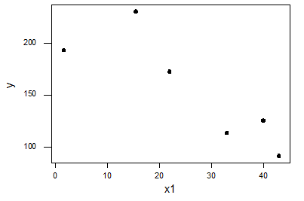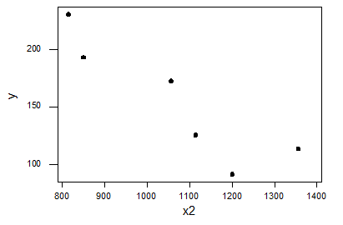

(plots, 10 pts)

Question 2. (30 pts)

The inside diameter (in inches) of 20 lightweight snaps used in assembling computer cases are measured and sorted with the following resulting data:

|  |  |  |  |  |
| --- | --- | --- | --- | --- |
| 39.5 | 44.3 | 45.0 | 45.9 | 47.0 |
| 48.5 | 48.6 | 48.7 | 48.9 | 49.6 |
| 49.9 | 50.0 | 50.3 | 50.4 | 50.4 |
| 51.6 | 52.9 | 54.2 | 55.0 | 57.1 |

Obtain a box plot for the data using an approximate scale and point out if any outlier is present.

Q1: (20+1)/4 th data point=5.25th data point. Interpolating 1/4th between 5th and 6th data point: Q1=47.0+(48.5-47.0)/4=47.375,

Q3: 51.3

Sample Median: (49.6+49.9)/2=49.75

IQR=3.92 1.5*(IQR)=6 (approx.)



Question 3. (20 pts)

The life of a semiconductor laser at a constant power is normally distributed with a mean of 7000 hours and a standard deviation of 600 hours.

1. (15 pts) What is the probability that a laser fails before 5000 hours?
2. (15 pts) What is the life in hours that 95% of the lasers exceed?

a) P(X < 5000) = 

= P(Z < −3.33)

= 0.0004. (+5 method, +5 correct answer)

b) P(X > x) = 0.95. Therefore,  = 0.95 and  = −1.64. Consequently, x = 6016.

(+5 method, +5 correct answer)

Question 4. (30 pts)

The length of time (in seconds) that a user views a page on a Website before moving to another page is a lognormal random variable with parameters θ = 0.5 and ω2 = 1.

1. (10 pts) What is the probability that a page is viewed for more than 10 seconds?
2. (10 pts) What is the length of time that 50% of users view the page?
3. (10 pts) What is the mean and standard deviation of the time until a user moves from the page?

X is a lognormal distribution with θ=0.5 and ω2=1

a)  (+7 method, +3 correct answer)

b) 

 (+7 method, +3 correct answer)

seconds

c) (+3 method, +2 correct answer)

 (+3 method, +2 correct answer)